**35. Design DFA using simulator to accept strings in which a’s always appear tripled over input {a,b}**

**AIM:** To design DFA using simulator to accept strings in which a’s always appear tripled over input {a,b}

**TRANSITION DIAGRAM:**

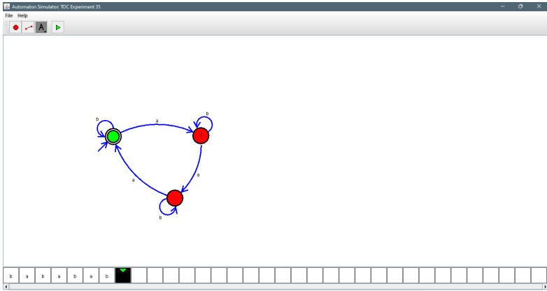

**RESULT:** Hence designing DFA using a simulator to accept strings in which a’s always appear tripled